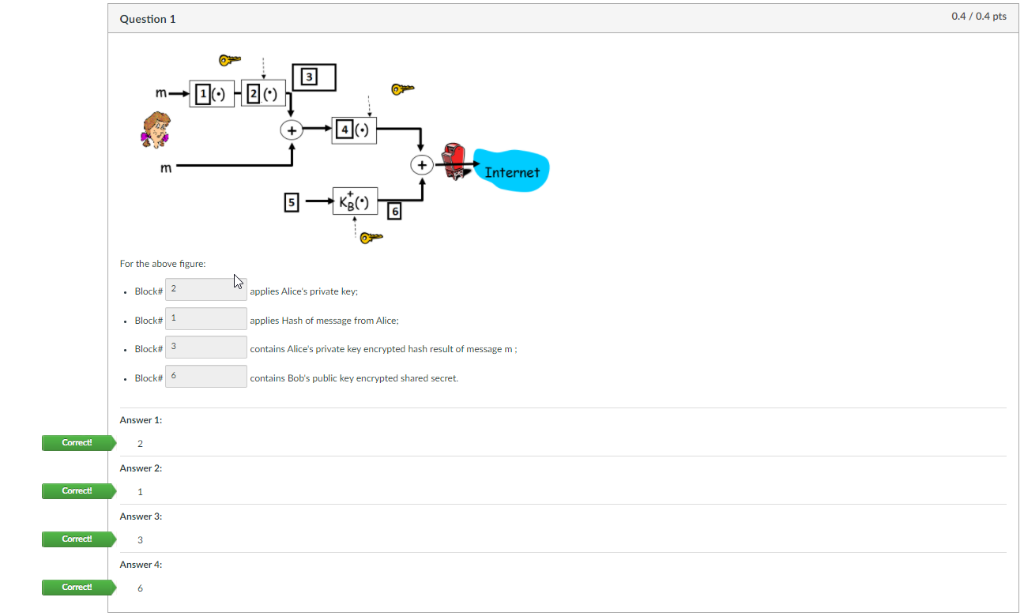

1. 2
2. 1
3. 3
4. 6

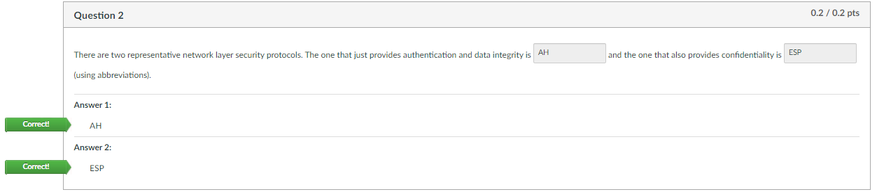

1. AH
2. ESP

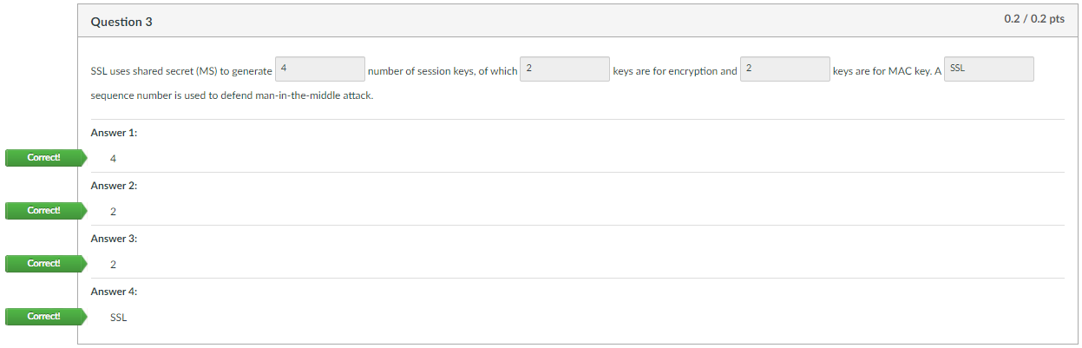

1. 4
2. 2
3. 2
4. SSL

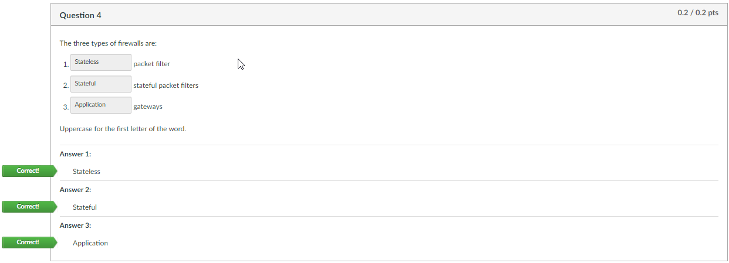

1. Stateless
2. Stateful
3. Application